**Experiment No. 1.1**

**Student Name: Rishav Kumar UID: 22MCC20039**

**Branch: MCA - CCD Section/Group: MCD-1/ Grp A**

**Semester: II Date of Performance: 15th Feb 23**

**Subject Name: Cloud Computing Lab Subject Code: 22CAP-687**

1. **Aim/Overview of the practical:**

Q.1 Create a google form that'll take the feedback of 6 subjects and you need to collect from students.

Q.2 Create a google sheet and enter their five subject’s marks for 10 students. Calculate the sum, average, max marks, min marks scored by the students in every subject.

1. **Code for practical:**

**Q1. Create a google form that'll take the feedback of 6 subjects and you need to collect from students.**

* Go to your Google Drive and click on the "**New**" button, then select "**Google Forms**" from the drop-down menu.

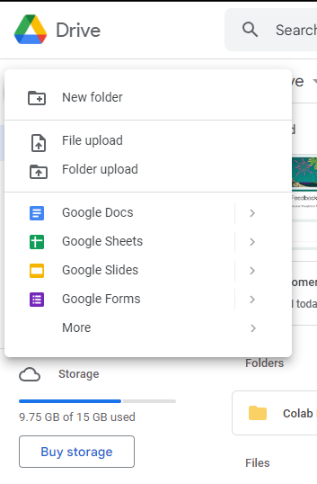

* Name your form in the top left corner.
* Click on the "Untitled Question" field and change the question to "Please select the subject you want to provide feedback for." Add six options for the subjects.
* Click on the "+" button to add a new question, and change the question to "Please provide your feedback for the selected subject."

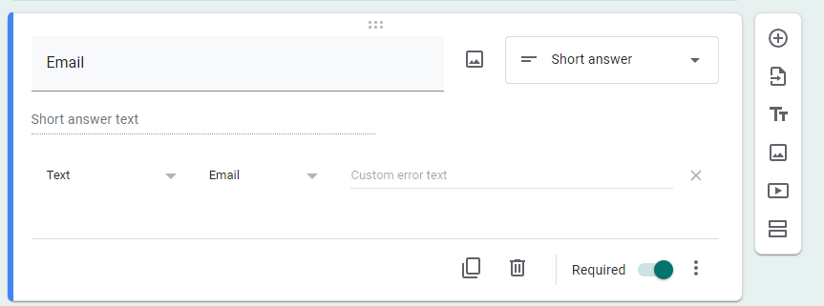

* Click on the "+" button to add a new question, and change the question to "Which faculty taught the subject?"
* Add options for the faculty for each subject.
* Click on the "+" button to add a new question, and change the question to "How satisfied are you with the teaching of the faculty member?"
* Add a rating scale of 1 to 5 for the response options.
* Click on the "+" button to add a new question, and change the question to "Would you recommend the faculty member to your peers for this subject?"
* Add "Yes" or "No" options for the response options.
* Customize the theme and design of the form as per your preference.
* Click on "Settings" at the top right corner of the form, and enable "Response receipts" to send an automated email to respondents after submitting the form.

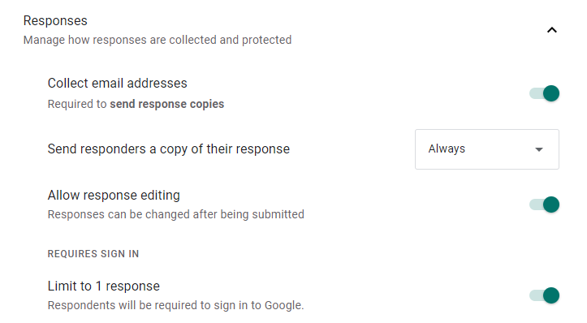

* Click on "**Send**" at the top right corner of the form, and select the sharing method for the form (via email, link, or embedding on a website).

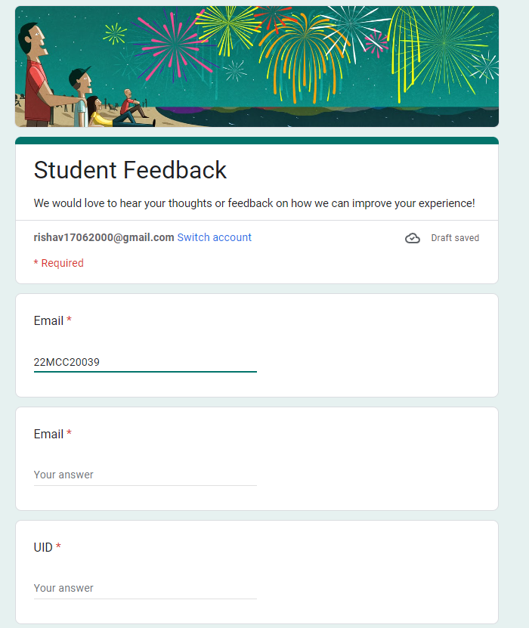

* Once the form is shared, you can view the responses in the "Responses" tab of the form.

**Q2. Create a google sheet and enter their five subject’s marks for 10 students. Calculate the sum, average, max marks, min marks scored by the students in every subject.**

* Go to your Google Drive and click on the "New" button, then select "Google Sheets" from the drop-down menu.



* Name your sheet in the top left corner and create column headers for "Student Name" and the five subjects you want to track.
* Enter the names of the ten students in the first column.
* Enter the marks scored by each student in each subject in the corresponding columns.
* To calculate the sum of each student's marks in a subject, select the cell next to the last student's marks in that subject's column, type *"=SUM(C2:H2)"*, and press enter. Drag this formula down for each subject to calculate the sum for each student.

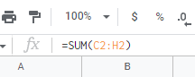

* To calculate the average of each student's marks in a subject, select the cell next to the last student's marks in that subject's column, type *"=AVERAGE(C2:H2)"* and press enter. Drag this formula down for each subject to calculate the average for each student.
* To calculate the maximum marks scored by any student in a subject, select the cell next to the last student's marks in that subject's column, type *"=MAX(C2:H2)"* and press enter.
* To calculate the minimum marks scored by any student in a subject, select the cell next to the last student's marks in that subject's column, type *"=MIN(C2:H2)"* and press enter.

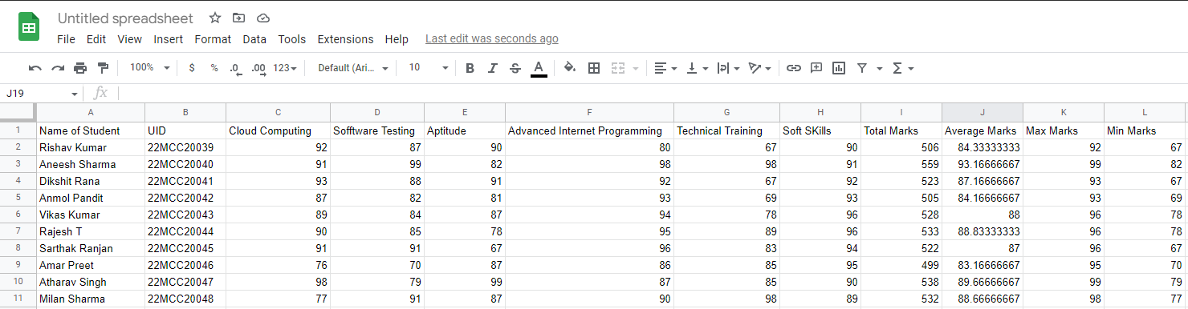

* Drag the formulas from steps 5-8 to the other subjects' columns to calculate their sum, average, max, and min marks scored.

**************************************** **THE END** ***********************************************